Chair of International Law
Master's Degree in Law
Department of Law

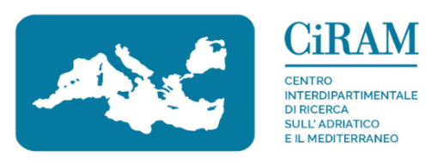

Specialized Lecture

Unveiling the (Eurocentric) Foundations of International Law
A re-reading of the colonial injustices

Rachele Marconi
University of Macerata

Introduction
Andrea Caligiuri
University of Macerata

Friday | 21 April 2023
11h00 a.m.

Room B | Law Department
Piaggia dell’Università 2 | Macerata

